**Charles Sturt**

**University**

**Assignment 1**

**Basic Algorithms in Java**

# Report File with Java and Class files

**Name: Shreyas Bharadwaj N R**

**Student ID: 11645440**

**Email ID:** [**shreyasnr6666@gmail.com**](mailto:shreyasnr6666@gmail.com)

**Lecturer Name: Recep ULUSOY**

## **Task 1**

**Screenshots:**

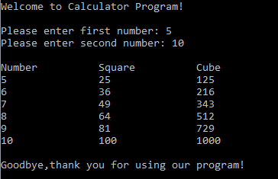

**Logic Explanation:**

Task 1 is to calculate the square and cube of the range of numbers entered by the user.

User will enter 2 numbers here. One is the start of the range and other is the end of the range.

We have used for loop here. The loop will work until it reaches to the end point that is the second number entered by the user. Each time the loop will work, it will display the square and cube of the number.

**Square and Cube Calculator:**



## **Task 2**

**Screenshots:**

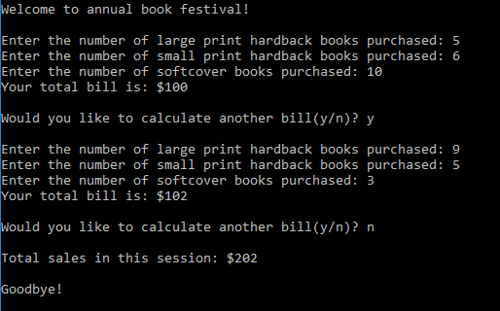

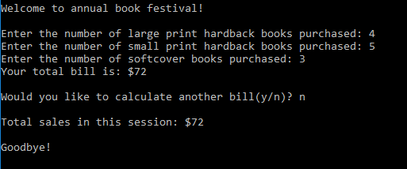

**Logic Explanation:**

Task 2 is for calculating the total bill each time user enters the details.

User will enter three inputs as mentioned in the screenshots.

For calculating the bill, we have used while loop which will terminate when the input entered by the user becomes 0 or less than 0 after the calculation. The same logic will be used for other two inputs. Charges will be changed according to the input entered that is for large print hardback books $10 for each or three books for $20. Similarly, these values will be changed according to the inputs.

Another while loop has been used to ask the user whether to enter the values again.

* If user enters ‘y’, then the user will enter all the details again.
* If user enters ‘n’, program will be terminated with the exit message and total bill will be displayed on the window.

**Book Purchase:**

